Head and neck:

TNM principles :

TNM* calculator online :

<https://www.canstaging.org/tool>

TNM8 staging questions help desk:

<https://www.uicc.org/resources/tnm-help-desk>

TNM online journal :

<https://onlinelibrary.wiley.com/doi/book/10.1002/9780471420194>

Head and neck cancer TNM staging

Fundamentals :

1. Nodal staging
   1. For all head and neck cancer N staging is same except for -:
      1. Nasopharyngeal cancers
      2. Malignant melanoma (mucosal)- these are very aggressive tumors, so it is also worthwhile to remember, that T1 and T2 stages are omitted from TNM staging of these tumors.
      3. Thyroid
   2. Midline nodes are considered ipsilateral nodes
   3. Magic numbers for nodal staging are 3 and 6 cm
   4. ENE is new addition to nodal staging in TNM and it upgrades the staging – any node with ENE is at least N2a( if < 3cm) and may be N3(size > 3cm).
   5. While considering the lymph node size as criterion for pathological nodal staging-for the purpose of staging, consider the size of metastasis node the size of node itself.
   6. ITS- isolated tumor cells – or micro metastasis : this means tumor detected in nodes only by H&E stains or immunohistochemistry. These are very small foci of metastasis and as such nodal stage remains N0- but a “i+”specification is added(that is N0(i+))
2. T staging :
   1. Clinical T staging:
      1. TNM8 introduces T4a and T4b category
      2. 2 and 4 cm are the magic numbers for size and 5mm and 10 mm are magic numbers for DOI
      3. If the tumors is involving two or more subsites- the classify according to where its epicenter is located.
      4. If there is invasive component present along with in situ- then stage according to only invasive component.
      5. For Lip and for cavity , there are slightly difference in different criterrons for T4a and T4b; for lip cancer- skin invasaion is NOT considered T4a (unless skin of chin or node is involved)- while for oral cavity cancers- skin involvement is T4a.
      6. Involvmeny of only cortical bone is not T4a (involvement of spngiosa is warranted).
   2. pT staging:
      1. for < = T3 tumors-: pT staging is requires pathological examination of primary carcinoma with no gross tumor visible at margins during resection (microscopic involvement is allowed, but macroscopic tumor should not be there are resection margin).
      2. For pT4a or pT4b- no resection is done. But microscopic confirmation of invasion through the different structures mentioned in corresponding categories is needed.
3. M staging:
   1. cM1 is clinical distant metastasis. When is microscopically confirmed it becomes pM1.
   2. While cM0 is valid , but pM0 or pMx are not valid categories
4. Overall stage grouping :
   1. M1 straight away makes stage IVC
   2. N3 (that is node > 6cm or presence of ENE) OR T4b– straightway makes stage at least IVB
   3. Similarly- T4a or N2- makes stage at least IVA.
   4. Stage I is easy- T1N0M0
   5. Stage II is easy : T2N0M0
   6. Rest all are Stage III (N1 or T3 makes stage at least III).
   7. In nutshell- the T stage directly correlates with overall stage _ that is T1, T2, T3 ,T4a and T4b are accordingly at least Stage I, Stage II, Stage III, Stage IVA or Stage IVB respectively.
   8. M1 is always Stage IVC
   9. N score correlation with final stage is more complex. N stage effect prognosis quiet severely. There the effect of N score is disproportionally high on final staging.
      1. N0 obviously will have no impact at all on final staging- and staging for all N0 tumour will be solely based on T score and M score which is quiet straight forward as explained above.
      2. Even lowest N stage (N1)- will make final stage at least Stage III
      3. For N2 and N3- add 3 to the N score to get the final stage – for instance of N2- final stage - Stage IVA(4 + =5=2+3) HPV status; and for N3 final stage is IVB(4=2=6= 3+3)
   10. Y prefix descried staging after neoadjuvantchemotherapy.
       1. Tis is staged as Stage 0 prior to NAC
       2. However after NAC, tumorcan disappears making T as T0- so stage 0 fter NAC (that is Stage y0) is T0N0M0 and Tis after NAC is staged as Stage yis
5. HPV tumor status should be determined for all cases of newly diagnosed oropharyngeal squamous cell carcinoma. HPV tumor status is not appropriate for the routine evaluation of nonsquamous carcinoma of the oropharynx, or nonoropharyngeal squamous cell carcinoma of the head and neck. It may be useful in select cases of oropharyngeal cancer with uncertain histology. HPV status is not relevant for Hypopharyngeal cacners- these are staged as P16 -ve tmours. HPC status is relevant only for oropharyngeal and nasopharyngeal cacners.
6. For adult patients presenting with cystic neck mass, metastatic cystic squamous cell carcinoma associated with HPV needs to be strongly considered and excluded.
7. The preferred method for determining HPV tumor status is surrogate marker p16 immunohistochemistry [[4,5](https://www.uptodate.com/contents/overview-of-the-diagnosis-and-staging-of-head-and-neck-cancer/abstract/4,5)]. Overexpression of this surrogate marker is strongly associated with transcriptionally active high-risk HPV. The threshold for positivity is at least 70 percent nuclear and cytoplasmic expression with at least moderate to strong intensity. However, there can be false-positive and false-negative results; HPV in situ hybridization or polymerase chain reaction can be used to clarify HPV status when the clinical scenario and p16 results are discordant.

Nodal assessment by CT:

Pathologic lymphadenopathy is usually defined radiologically as a node greater than 10 to 11 mm in minimal axial diameter or one that contains central necrosis [[39-42](https://www.uptodate.com/contents/overview-of-the-diagnosis-and-staging-of-head-and-neck-cancer/abstract/39-42)]. The choice of how a lymph node is measured is often controversial and reflects a tradeoff between sensitivity and specificity. In general, size criteria based on measurement of minimal axial diameter are considered the most accurate and effective [[43,44](https://www.uptodate.com/contents/overview-of-the-diagnosis-and-staging-of-head-and-neck-cancer/abstract/43,44)], and probably the most reproducible [[45](https://www.uptodate.com/contents/overview-of-the-diagnosis-and-staging-of-head-and-neck-cancer/abstract/45)]. Other features that suggest pathological lymph nodes include rounded shape, loss of normal fatty hilum, increased or heterogeneous contrast enhancement, lymph node clustering, and sentinel lymph node location.

Extracapsular spread of nodal metastasis is an important prognostic factor that should be assessed on imaging. Imaging findings that suggest extracapsular spread of nodal metastasis include irregular border of the lymph node, infiltration of adjacent fat planes, and loss of cleavage plane with adjacent anatomical structures.

In most studies, CT scanning outperforms MRI for the detection of pathologic nodal metastases.

***PET scan should be done in ALL patients with nasopharyngeal and hypopharyngeal cancers.***

In patients presenting with cervical nodal metastases of unknown origin, the sensitivity of PET for detection of primary tumors is approximately 97 percent [[54](https://www.uptodate.com/contents/overview-of-the-diagnosis-and-staging-of-head-and-neck-cancer/abstract/54)]. A false negative is most likely seen in small lesions and in primary tumors located at pharyngeal lymphoid tissues with high background physiologic activity..

Negative PET/CT findings after chemoradiation may accurately determine early disease response, making further surgical intervention unnecessary.

OROPHARYNGEAL TNM

Treatment of oral cavity cancer is based on TNM 7 while prognosis is based on TNM 8 (which incorporates the DOI and HPV / p16 status).

Magic numbers are:

2cm(<2) : T1

And (2-4) : T2

4 cm(>4) : T3

T4- means locally advanced – if surgically resectable – 4a else 4b.

Nodal stage: magic numbers are

3 (<3) : N1

And (3-6): N2 (1 node = 1a, 2 node =1b, contralateral node = 2c)

6 (> 6): N3

Skin and bone involvement is always T4a (both in TNM7 and TNM8). But extrinsic muscle involvement has now been removed from TNM8 and this has been replaced by DOI.



Horizon- imagine mucous membrane

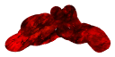

Thickness

DOI

T staging-: Key stage in T staging of H&N cancer are as follows-:

Size – key sizes are 2cm, 4cm

DOI: Depth of invasion- key numbers are 5mm and 10 mm

Anything which stays below minimum size and DOI criterions is T1 (< 2cm in size and DOI < 5mm is T1)

If both DOI and size goes beyond max allowed -: it is T4 (Size > 4cm in size + DOI > 10 mm )

Others are either T2 or T3

T2: < 2cm + DOI > 5mm (but < 10mm)

Or

2-4 cm but DOI < 10mm

T3: > 4cm but < 10 mm DOI

Or

2-4 cm with > 10 mm DOI

All local invasions are T4

--

N staging:

Key numbers are

3cm and 6 cm

And other aspect is ENE

Anything below minimum allowed is N1 : that is < 3cm / single / ipsilateral and no ENE

Anything above maximum allowed is N3: that is > 6m or ENE present.

Others are N2

**Important caveats while staging:**

1. TNM8 introduces DOI and removes external muscle involvement
2. TNM8 introduces ECS
3. Perinerual spread and crossing the midline is not included in staging but important for management

5Ts

Larynx- Jacobson nerve- twig of vagus nerve- tympanic nerve- is supplied by Vagus/ glossofpharngua / facial / trigewminal

1. Throagt
2. Tongue
3. Teeth
4. Tonsil
5. TMJ

Orophargenal tumors – features to upgrade to T4a/T4:

1. Styloglosus muscle involvement
2. Hygoglosus involvement
3. Medial pterygoid involvement.

T4B features of the oropharyngeal involvement:

1. Lateral pterygoid involvement
2. Nasopharynx

Hard palate tumors ;

T41 upgrade if bone is involved.

Involvement of the pterygoid plate – is T4b

Perineural involvement: 2 nerves comes posteriorly from – higher and the larger is maxillary – foramina rotundum- immediately laterally to sphenoid sinus.

Inferiorly is vidian nerve- it is seen just medial to foramn rotundum in coronal ct.

Anatomy – basic:

Dividing nasopharynx from oropharynx- rule of thumb – use midpoint of dense in sagittal images.]

Dividing -oropharynx from hypopharynx- use epiglottis base

Divide deep fascia – divide into superficial deep- mid (visceral deep) and deep deep:

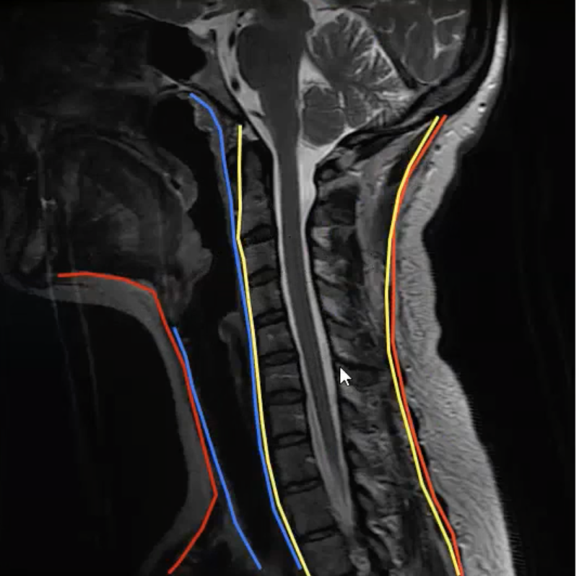

Retropharyngeal space= lies deep to visceral space and just anterior to alar fascia (cant see in imaging)- extend down to T4

Danger space-lies between retropharyngeal space (alar fascia) and deep paravertebral space – extend down up to diaphragm.

Pletonia defects – cn happen in lateral myelohyoid- plunging ranula.

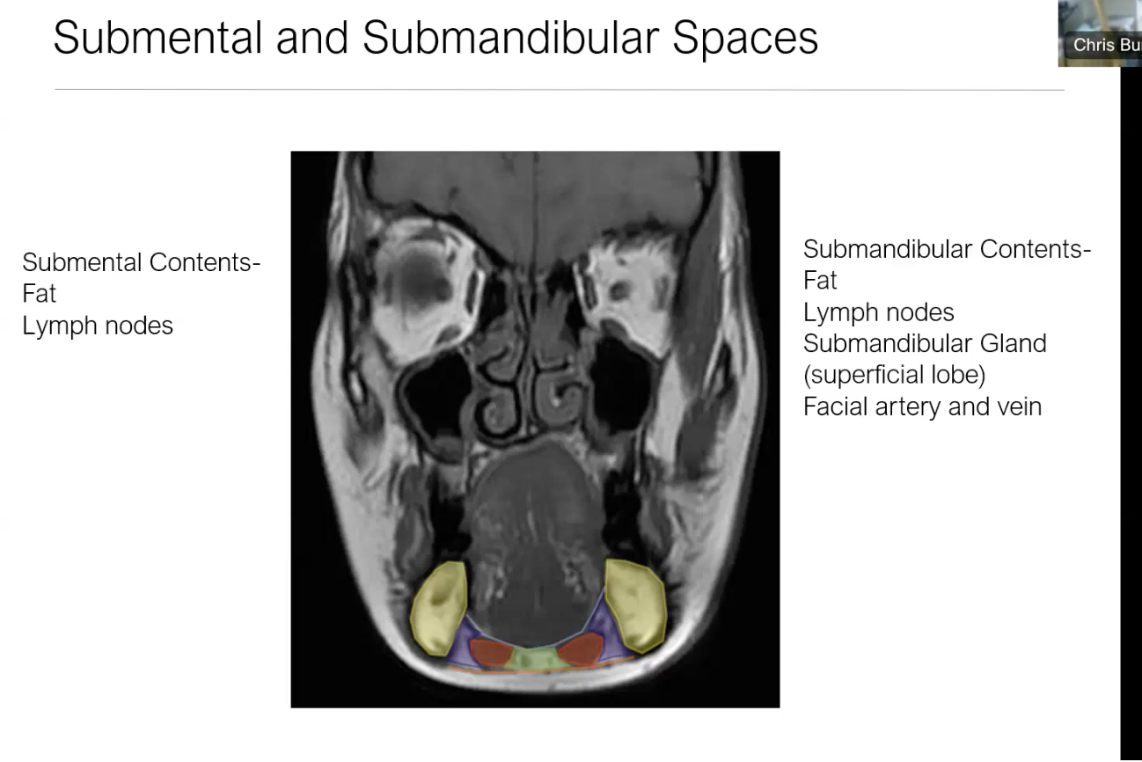

Sublingual glands lie just lateral to genoglosus muscle

SMG has deep and superficial parts

Lateral pterygoid is very horizontal muscle- it more superior to the medial pterygoid.

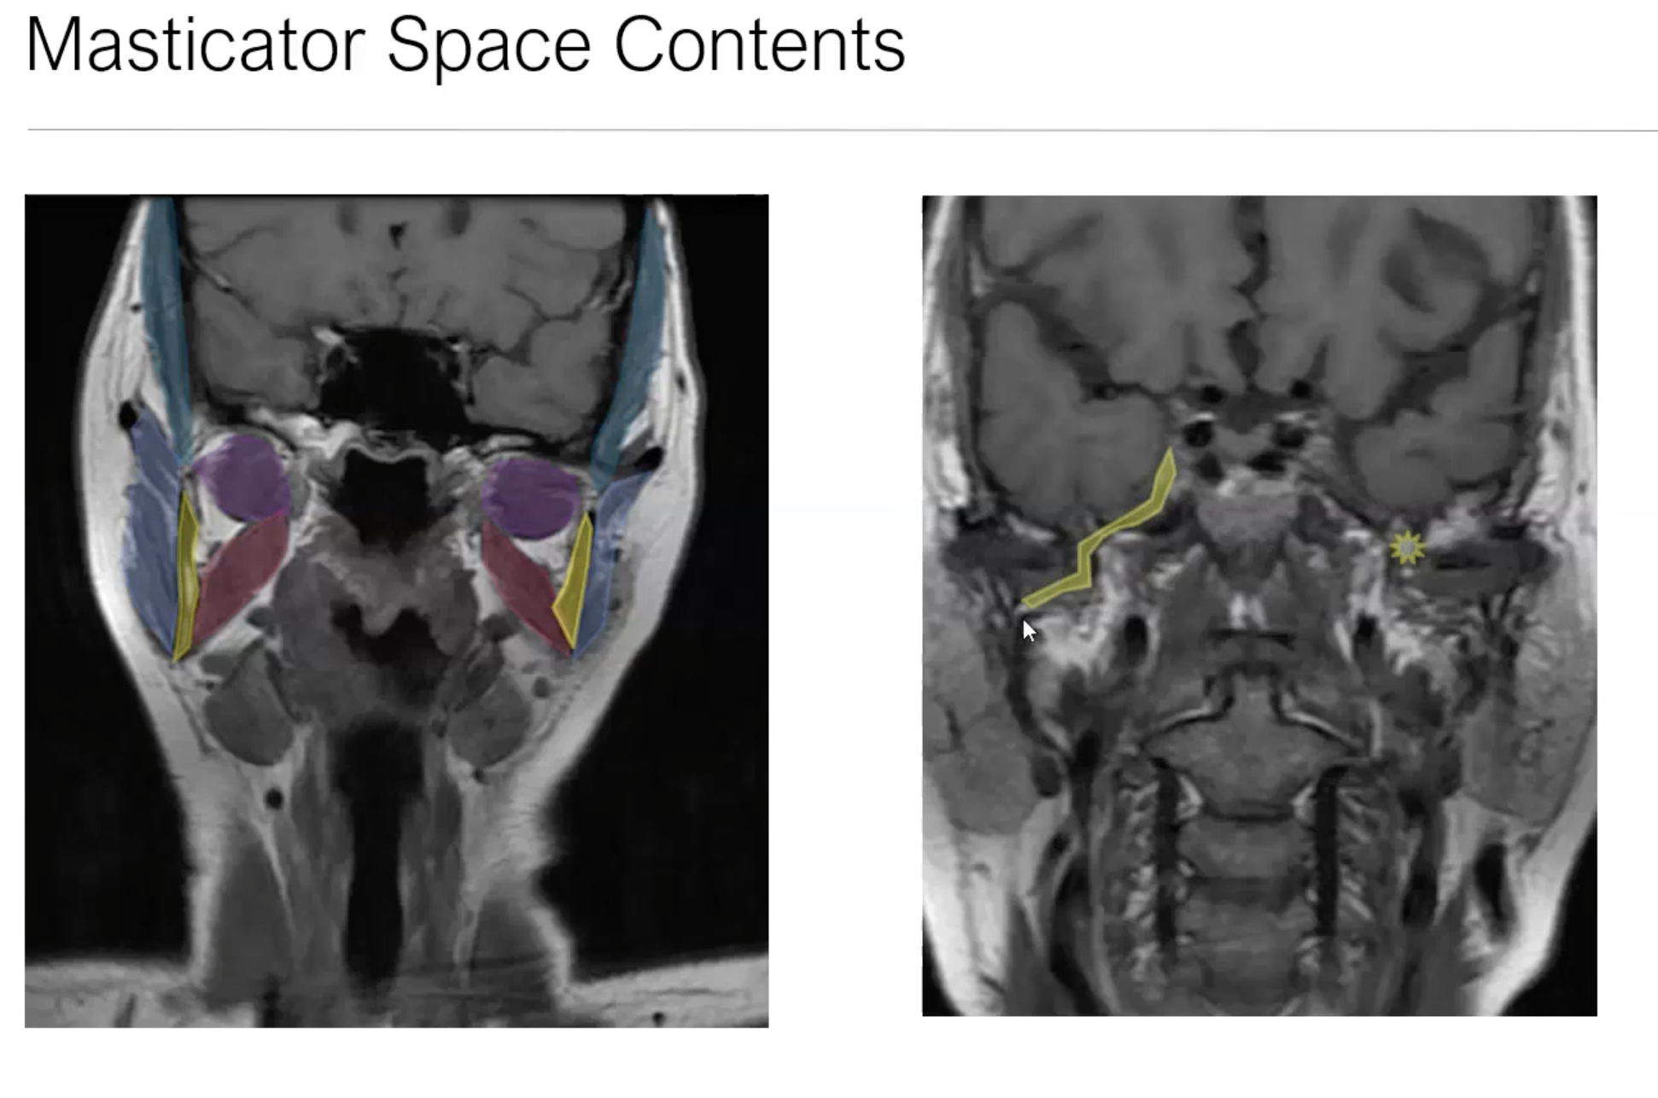

Trig nerve from meckels cave

For. Ovale

Zyg

Mand

MP

Masseter

Temporalis

LP

*Keep mandibular condyle as landmark and scroll downwards to identified various part of mandible to assess masticator spaces.*

*Use meckel’s cave as landmark and scroll downwards to assess foramen ovale and trigeminal nerve.*

SMG do not have nodes within it (unlike parotid)- this is because it get encapsulated before lymphatics develop.

Retromandibular vein- divides parotid deep v/s superficial and **demarcated facial nerve** which lie lateral to it. RMV lies just posterior to mandibular condyle in the parotid gland in axial images.

Also keep in mind stylomastoid foramina as land mark while trying to identifying facial nerve.

Course of facial nerve:

* Comes out IAM-
* First genu- gives of **greater petrosal nerve** shooting out anteriorly. Continues downwards (as tympanic portion)
* Second genu to enter mastoid – mastoid portion
* As it goes down in mastoid , gives of **Chorda tympani anteriorly** – chorda tympani is recurrent nerve and goes back to middle ear.
* Finally facial nerve exits stylomastoid foramina and enters parotid running posterior to the retromandibular vein.

Keep in mind accessory parotid gland.- lies anteriorly , lateral to masseter muscle.

Parotid duct opens into second molar.

Muscles of nasopharynx:

Superior constrictor-

Palato-glosus

Palato-pharyngeus

Levato-palati

Levvator- tensi

Styloid – three muscle –

* posterior belly of digastric
* Stylopharyngius
* Styloglosus- no more considered to change staging if involved in tongue tumors (extrnisic muscle)

Differentiate between – anterior to posterior***: retroharyngeal space – alar fascia – danger spsce- prevertebral muscle- prevertebral space.***

***Contents of parapharyngeal space: extends from skull base down to hyoid.Its communicate with SMG space.***

**Ascending pharyngeal artery**

**Internal maxillary artery**

**Pharyngeal venous plexus**

**Salivary rests.**

**No lymph node ! NO nerve !**

**HYPOPHARYNGEAL CANCER TNM:**

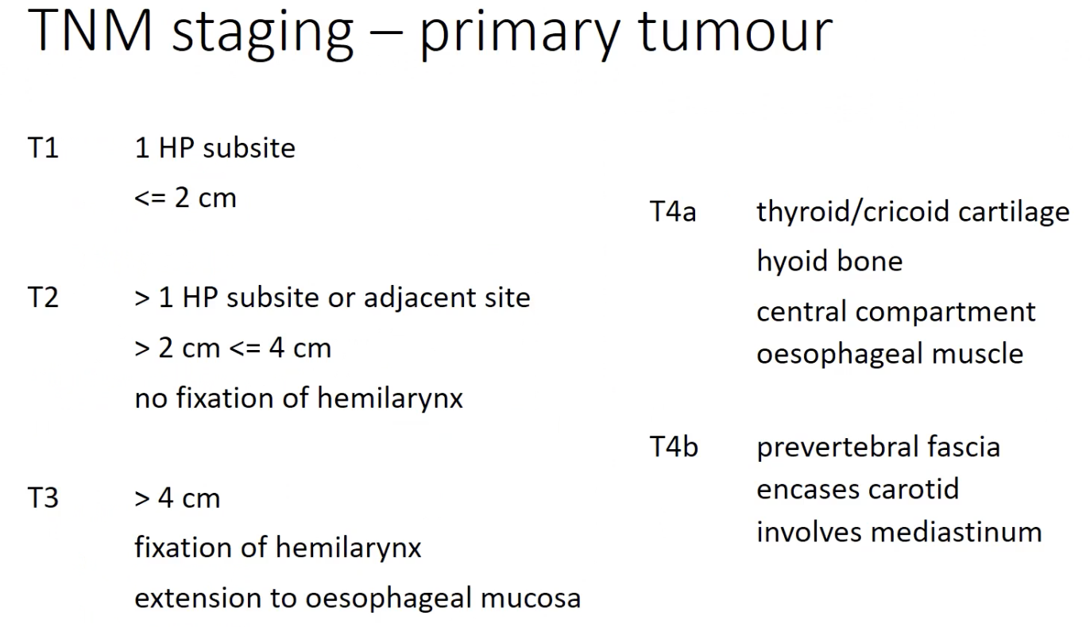

**T1 rare in hypopharynx – may be amenable to transoral surgery.**

**Most T2/T3- radiotherapy**

**T4 is the key radiological concern- as T4 will mean need for total pharyngeolaryngectomy + bilateral radicsl neck node dissection. So this become very important to diagnose :**

**So look for :**

**Thyroid or cricoid cartilage involvement- difficult to diagnose cartilage invasion.**

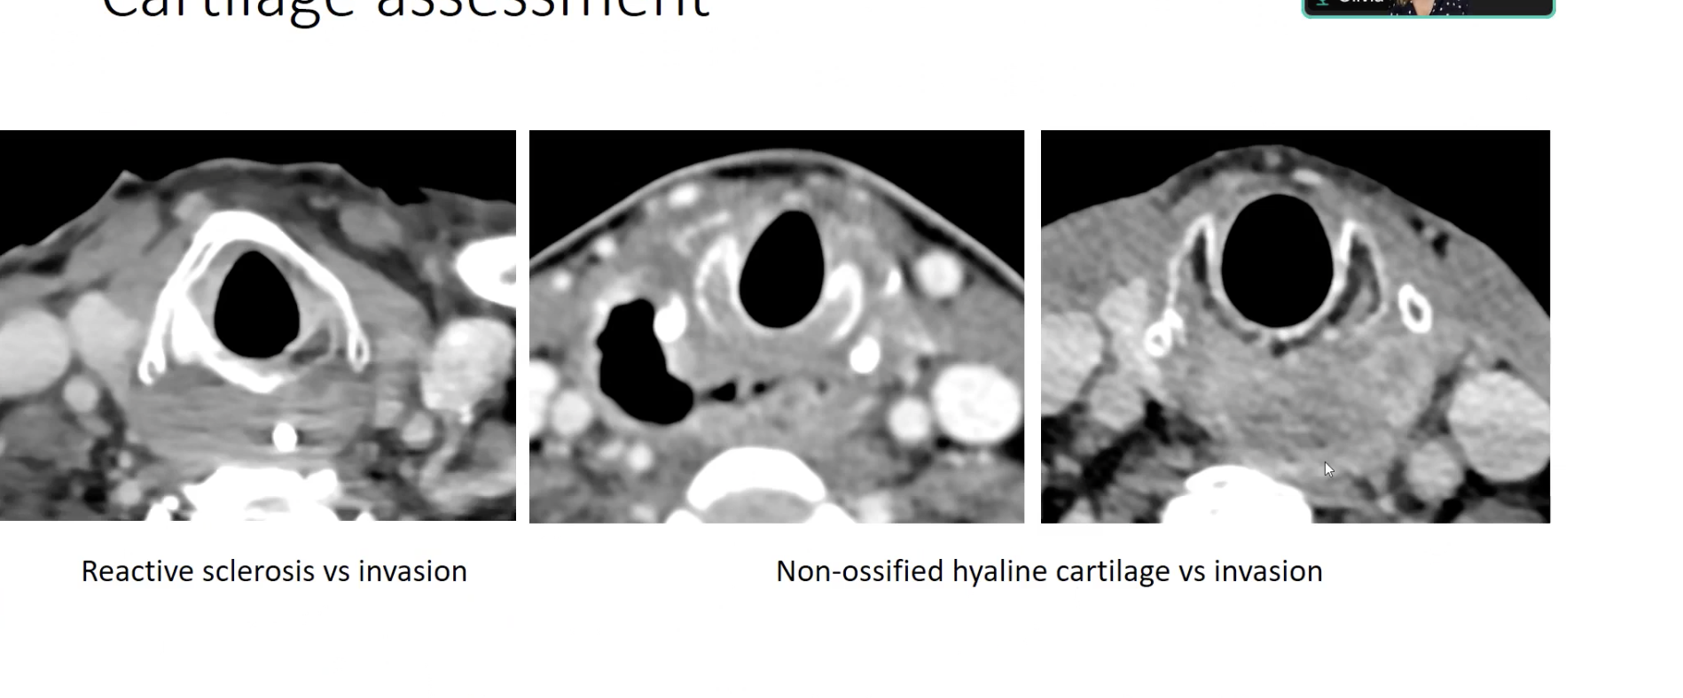

**MRI is more accurate in cartilage invasion : Becker M paper (open access) on MRI assessment of cartilage invasion.**

**Hyoid bone involvement**

**Soft tissue or esophageal muscle.**

**Assessment of prevertebral fascia is difficult – so diffuclt to diagnose T4b.**

**Node involvement :**

**Even presence of N1 disease (single node < 3cm) upstage the disease immefiately to stage 3 !!**

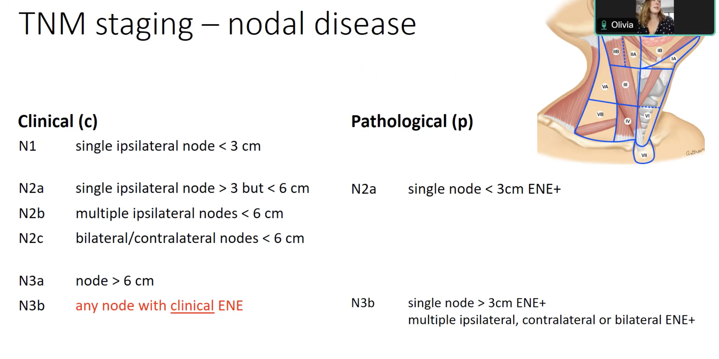

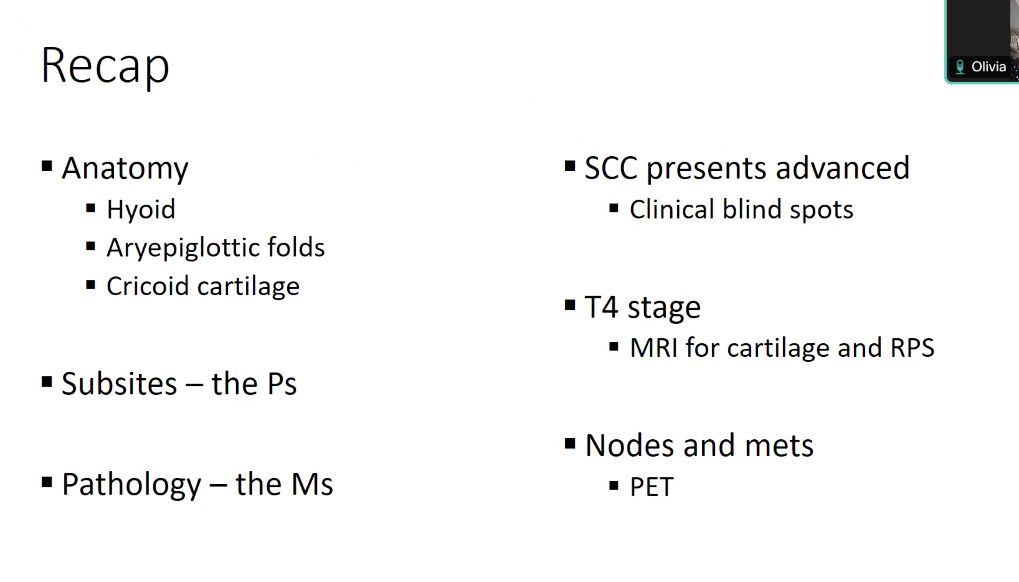

Temporal bone:

**Level of tympanic membrane retractions:**

**Level I retraction — There’s no contact with any of the bones of the middle ear.**

**Level II retraction — The tympanic membrane contacts the middle ear bone.**

**Level III retraction — The middle ear cavity starts to narrow because of the retracted eardrum.**

**Level IV retraction — The retracted eardrum gets stuck in the middle ear space because of chronic inflammation.**

**Petrous apex lesions :**

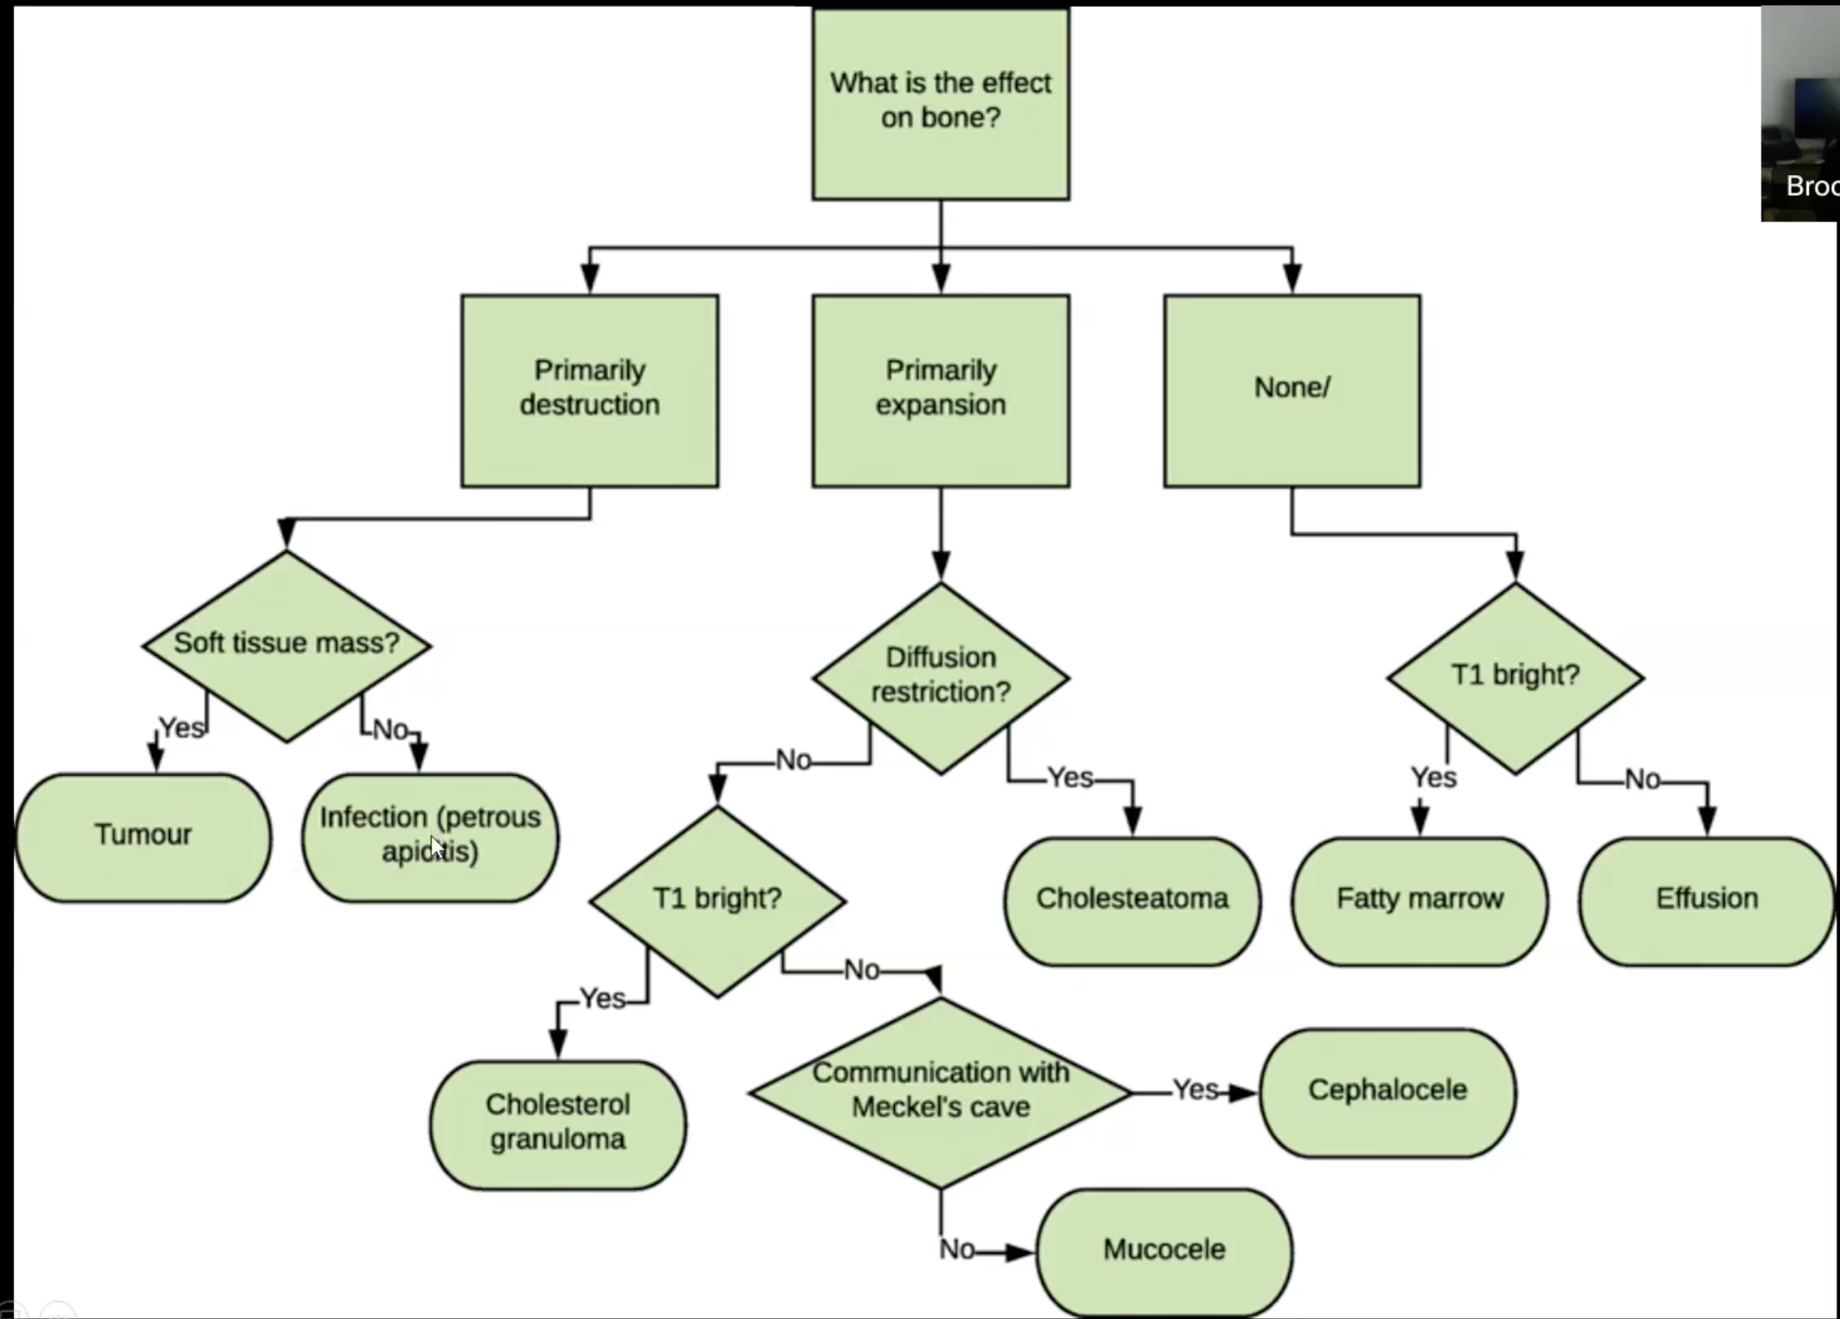

**Good paper: Petrous apex lesions: pictoral reviews : SEJ Connon R Leung**

**Arrested pneumatization : Welker’s criterion – do not touch lesion.**

**Can occur in petrous apex- tricky diagnosis.**

**Alos can occur around sphenoid :**

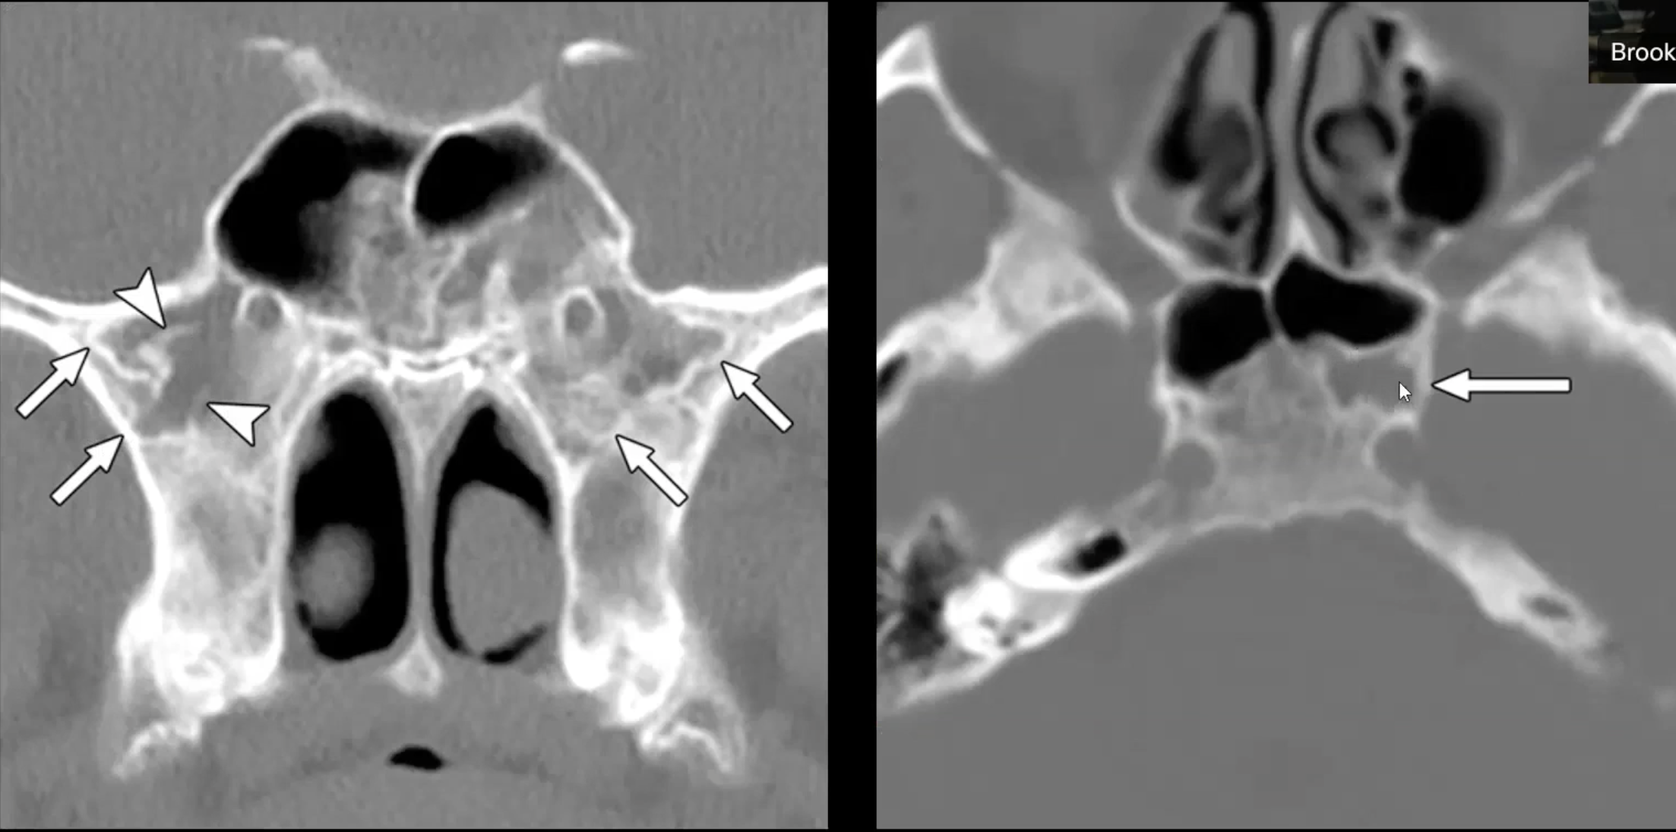

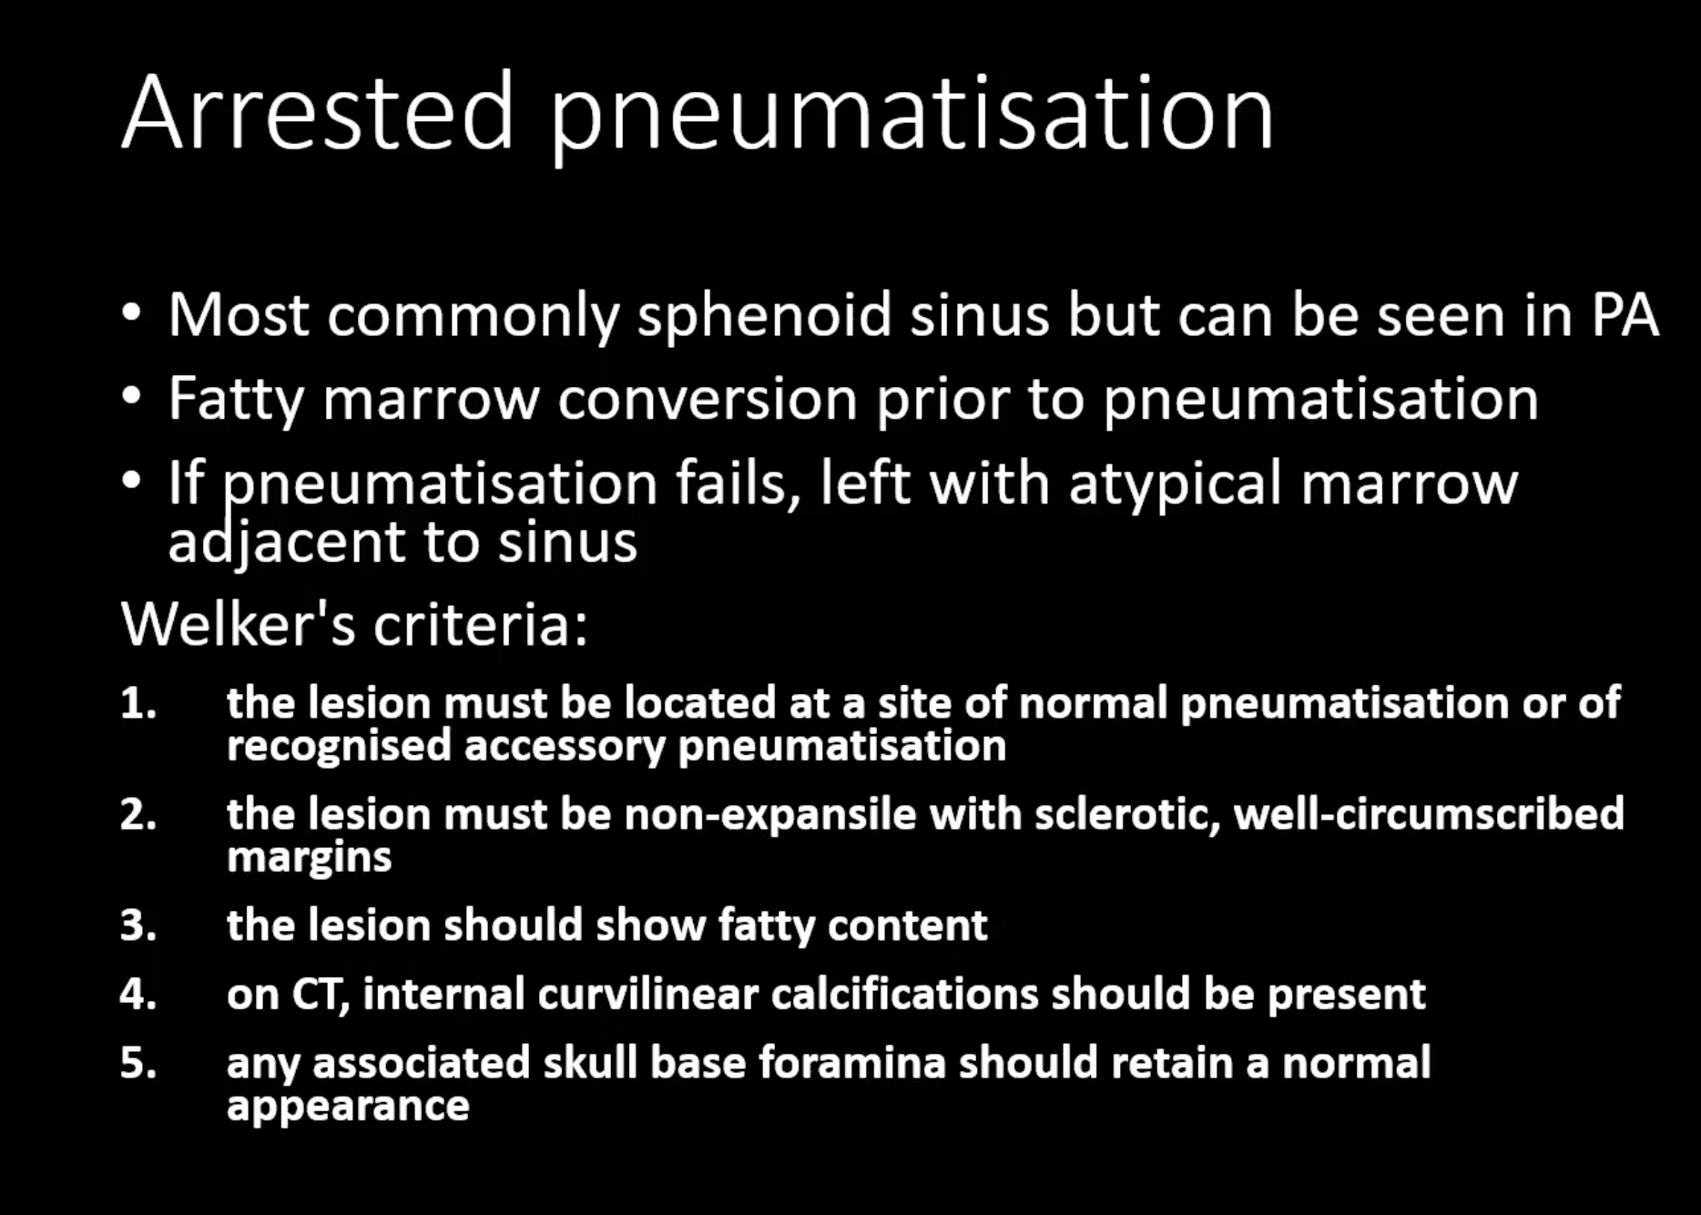

**Congenita EAC atresia:**

**Also think of :**

**Surfers ear (acquired EAC stenosis)**

**Keratosis obturans**

**EAC osteoma**

**EAC choleasteatoma**

**Medial canal fibrosis**

While reporting consider Jahrsdorfer scoring : 10 Pooint syste. > 5 score consider surgery. If < 5- no surgery. Score of 8 means 80% chances of success of surgery (surgery done at 5-6 years). CT to be done only later childhood prior to surgery as we must give time to middle ear to mature. Baha is surgically implantable system which works through direct bone conduction- alternative to surgery in unilateral EAC atresia.

Scoring system proposed by Jahrshdofer:

1. Appearance of external ear: 1
2. Middle ear space : 1
3. Maleus-incus complex : 1
4. Incus stapes connection : 1
5. Stapes present: 2
6. Oval window open: 1
7. Round window : 1
8. Facial nerve : 1
9. Mastoid pneumatized

**Middle ear opacification :**

**Traumatic v/s non traumatic**

**Traumatic :**

1. Otic capsule intact
2. Otic capsule violated:
   1. Internal auditory canal involved.
   2. Internal ear structures involved.
   3. Facial nerve canal involved.
   4. Ossicular chain involved.
   5. Carotid canal involved.

**Non traumatic :**

1. Non infectious – Eustachian tube dysfunction = secretory otitis. Glue ear is complication of long standing secretory otitis - middle ear fluid can become very thick and glue-like (“glue ear”), which increases the likelihood of conductive hearing loss. **Image findings :** Middle ear cavity and mastoid air cells are completely, homogeneously opacified. There is no ossicular chain erosion.
2. Infectious :
   1. Acute (no imaging needed) : Acute otitis media and acute otomastoiditis : Both from clinical and radiological points of view, it is important to differentiate between acute otitis media and secretory otitis. Secretory otitis means fluid in the middle ear cavity without signs or symptoms of infection; this is usually caused when the Eustachian tube patency is compromised, and fluid is trapped in the middle ear. Signs and symptoms of acute otitis media occur when effusion in the middle ear becomes infected.
   2. Complications (imaging needed) :
      1. Acute coalescent otomastoiditis (ACOM)-: resorption of inter-mastoid septa
      2. Intracranial extension
      3. Sigmoid sinus thrombus
   3. Chronic -: *Diagnosed if symptoms persist for >=6 weeks and otorrhea develops (which indicate tympanic membrane perforation).*
      1. With acquired cholesteatoma
      2. Without cholesteatoma :
         1. Post-inflammatory ossicular chain fixation :
            1. 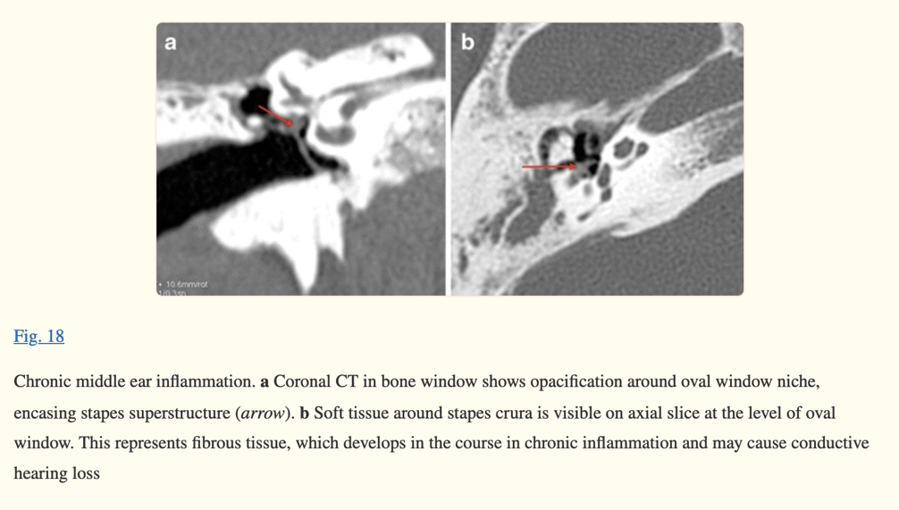Peri stapedial tent (fibrous tissue in the niche of oval window encases stapes).
            2. Tympanosclerosis, 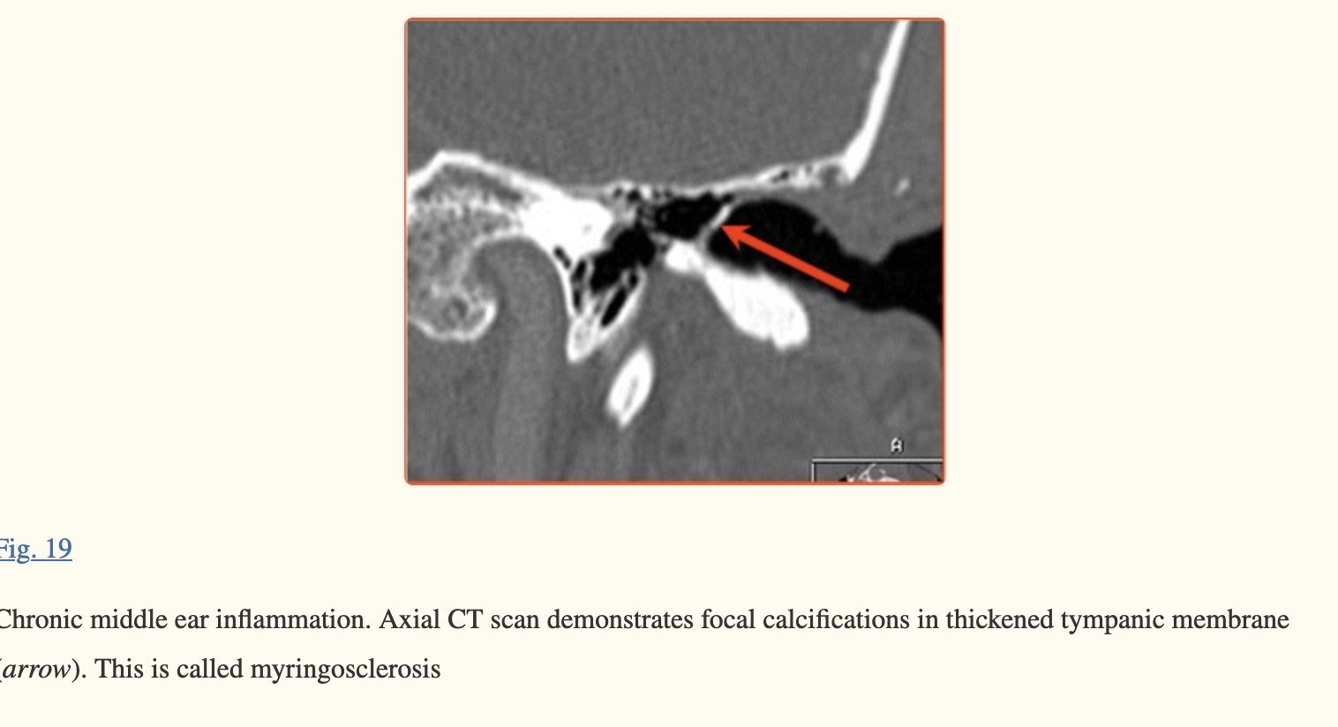 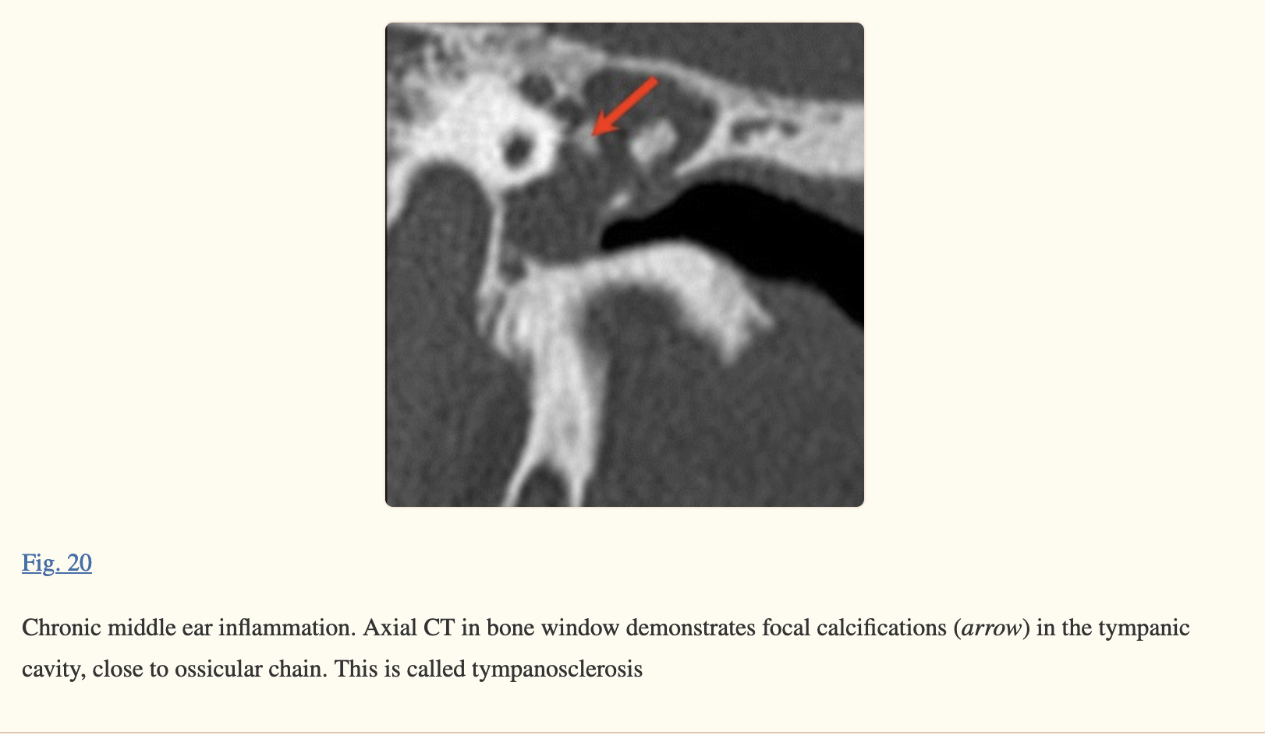which reflects deposits of hyalinised collagen in the tympanic cavity. If it occurs in tympanic membrane, it is called myringosclerosis (Fig. [19](https://www.ncbi.nlm.nih.gov/pmc/articles/PMC3292638/figure/Fig19/)). In the tympanic cavity, it may be present in any location, visible as focal calcified densities in the middle ear cavity, along tendons, also in direct apposition to the ossicular chain.
            3. Formation of new bone, rarely seen in the tympanic cavity, usually in epitympanum. Visible as lamellar structures of high density.
         2. Post inflammatory ossicular erosion : Post-inflammatory ossicular chain erosion is rather rare in case of a non-cholesteatomatous disease, but may seldom occur and will affect first the incus long process and lenticular process, followed by stapes head. In order to evaluate possible ossicular erosion, axial CT images should be searched for three distinctive signs:
            1. *“Ice cream cone”* visible in the epitympanum, where the anterior ice cream consists of the malleus head and the posterior cone is made of the incus body and short process (Fig. [21](https://www.ncbi.nlm.nih.gov/pmc/articles/PMC3292638/figure/Fig21/))

[[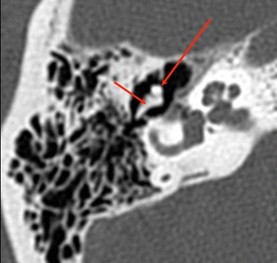](https://www.ncbi.nlm.nih.gov/pmc/articles/PMC3292638/figure/Fig21/)](https://www.ncbi.nlm.nih.gov/pmc/articles/PMC3292638/figure/Fig21/" \t "figure)

[Fig. 21](https://www.ncbi.nlm.nih.gov/pmc/articles/PMC3292638/figure/Fig21/)

Normal anatomy of middle ear. Axial CT, bone window. Malleus head (*long arrow*) and incus body (*short arrow*) with short process are visible in epitympanum, forming a so-called “ice cream cone”

* + - * 1. *“Two parallel lines”* visible in the mesotympanum, where the anterior line represents the malleus handle and the posterior line represents the incus long process (Fig. [22](https://www.ncbi.nlm.nih.gov/pmc/articles/PMC3292638/figure/Fig22/))

[[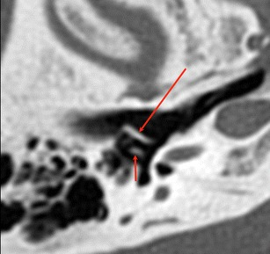](https://www.ncbi.nlm.nih.gov/pmc/articles/PMC3292638/figure/Fig22/)](https://www.ncbi.nlm.nih.gov/pmc/articles/PMC3292638/figure/Fig22/" \t "figure)

[Fig. 22](https://www.ncbi.nlm.nih.gov/pmc/articles/PMC3292638/figure/Fig22/)

Normal anatomy of middle ear. Axial CT, bone window. Malleus handle (*long arrow*) and incus long process (*short arrow*) are visible, forming two parallel lines

* + - * 1. *“Two dots”* visible in the mesotympanum, the lateral dot being the lenticular process and the medial dot being the stapes head—between them the incudostapedial joint is well visible (Fig. [23](https://www.ncbi.nlm.nih.gov/pmc/articles/PMC3292638/figure/Fig23/))

[[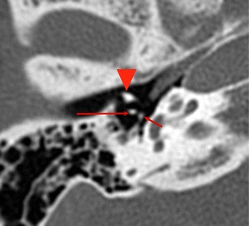](https://www.ncbi.nlm.nih.gov/pmc/articles/PMC3292638/figure/Fig23/)](https://www.ncbi.nlm.nih.gov/pmc/articles/PMC3292638/figure/Fig23/" \t "figure)

[Fig. 23](https://www.ncbi.nlm.nih.gov/pmc/articles/PMC3292638/figure/Fig23/)

Normal anatomy of the middle ear. Axial CT, bone window. Two dots, visible posteriorly to malleus neck (*arrowhead*) represent incus lenticular process (*long arrow*) and stapes head (*short arrow*)

* + - 1. Post-inflammatory erosion sometimes involves walls of tympanic cavity. Based on CT multiplanar images the following structures should first of all be evaluated:
         1. Bony cover of lateral semicircular canal
         2. Bony cover of the second (tympanic) segment of the facial nerve
         3. Roof of the middle ear cavity (tegmen tympani)

1. Others :
   1. 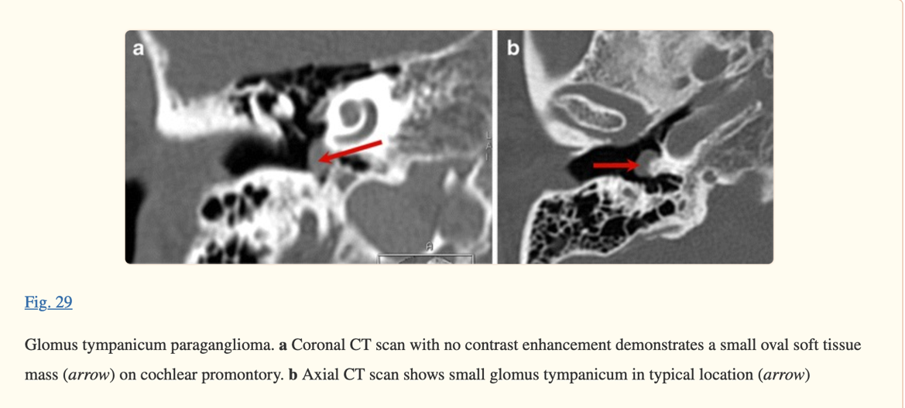Glomus tympanicum

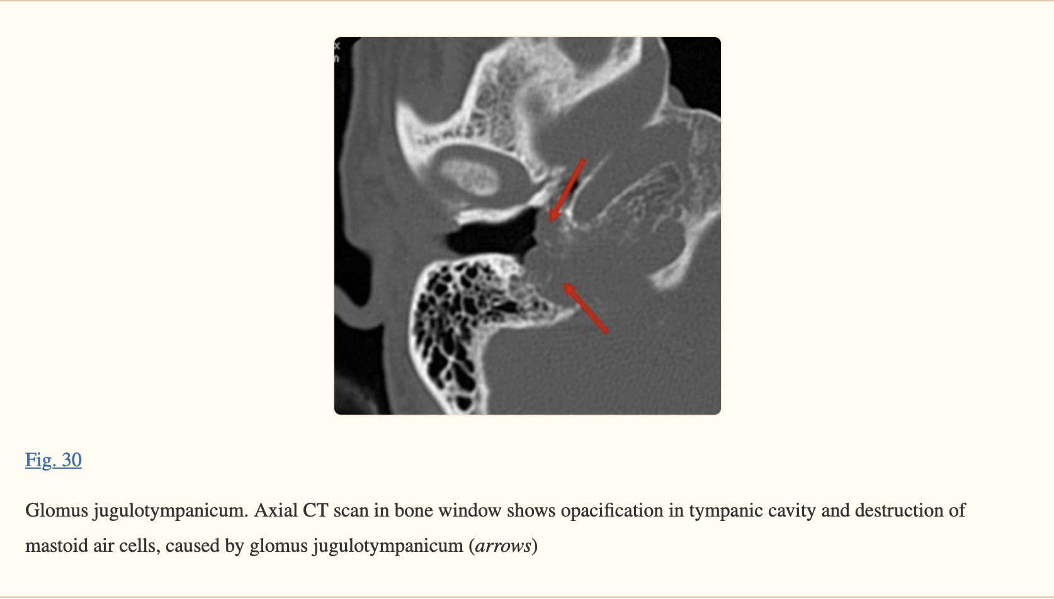

For the most efficient communication with ENT surgeons, GTP should be evaluated according to Glasscock-Jackson classification [[31](https://www.ncbi.nlm.nih.gov/pmc/articles/PMC3292638/#CR31)] (Table [4](https://www.ncbi.nlm.nih.gov/pmc/articles/PMC3292638/table/Tab4/)).

**Table 4**

Glasscock-Jackson classification of GTP

|  |  |
| --- | --- |
| Type | Description |
| Type I | Small mass limited to cochlear promontory |
| Type II | Tumour completely filling middle ear space |
| Type III | Tumour filling middle ear and extending into mastoid air cells |
| Type IV | Tumour filling middle ear, extending into mastoid air cells or through |
| Tympanic membrane to fill external auditory canal; may extend anteriorly to the carotid artery |

* + - * Middle ear Schwanoma : tumour arising within middle ear cavity, originating from the facial nerve, chorda tympani nerve (7th branch), Jacobson nerve (9th branch), or Arnold nerve (10th branch), with the facial nerve being the most common nerve of origin.

Protocols for Laynegeal CT:

Neck CT contrast protocol: 100ml contrast @ 1ml/sec- srtart scaning at 90-100 sec.

Plane of axial sections-: in the plane of hard palate (and coronal perpendicular to it)- see image below. 2mm slice thickness I adequate.

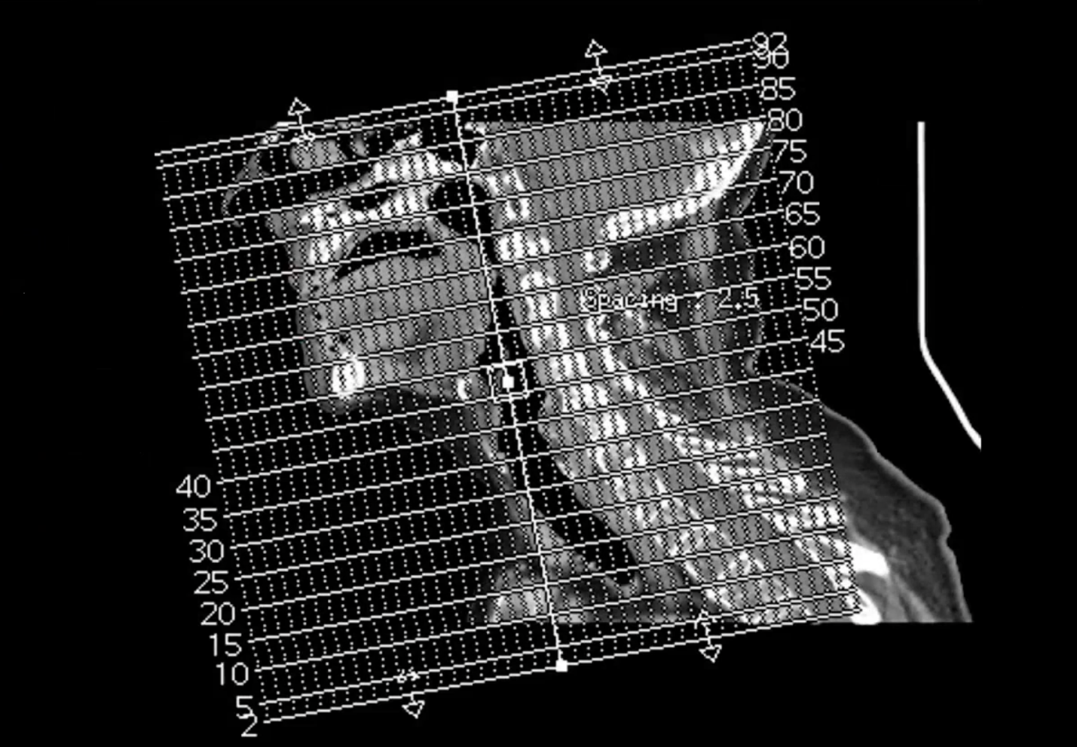

For larynx only – axial plane in the plane of intervertebral discs – see image below-: Need 1 mm slice thickness. Hyoid to thoracic inlet.

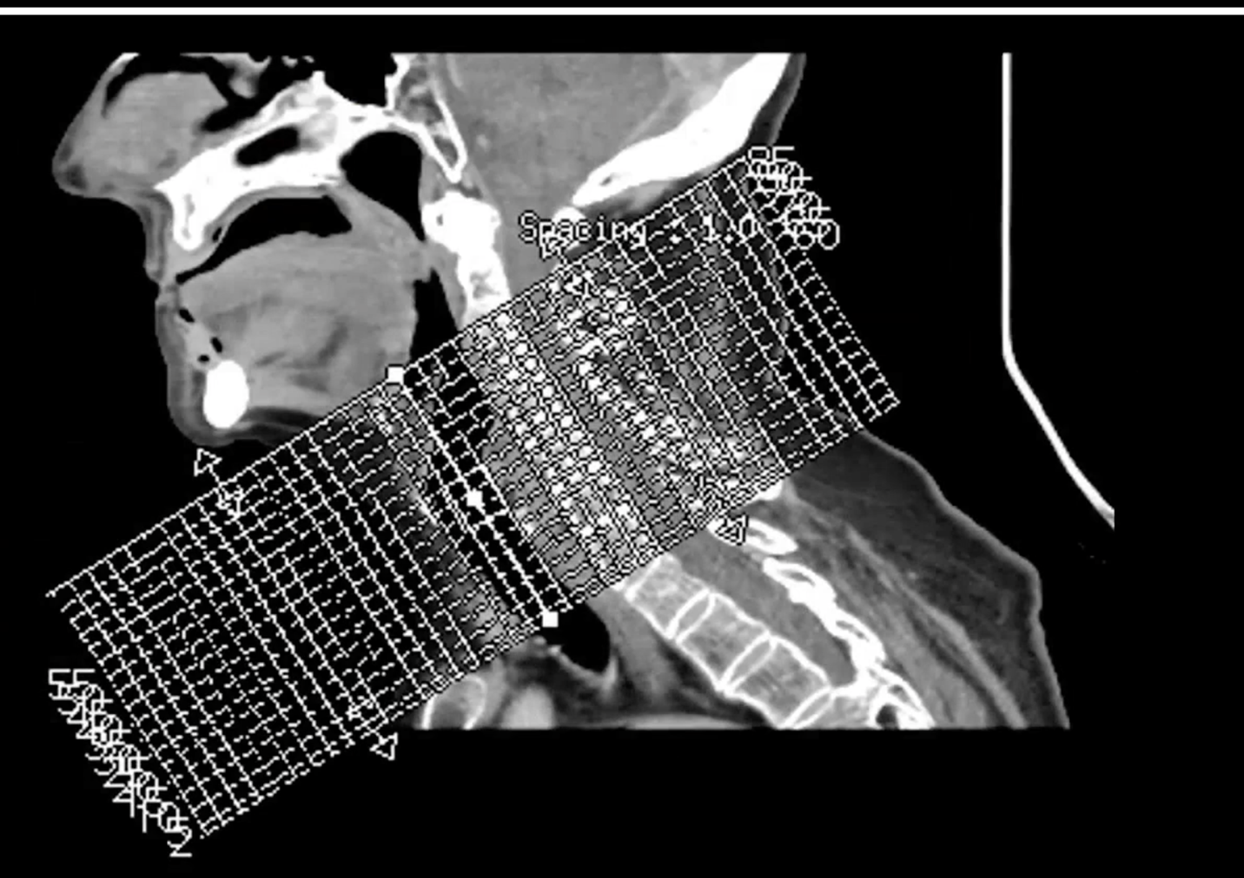

MRI protocol :

T1/ T2FS/T1 +T1FS Gado

Ax/Cor

DWI/ADC

Oral Cavity:

Anatomy :

Parts of oral cavity :

Floor

Hard palate (roof)

Buccal mucosa-:

Of upper lip

Of lower lip

Of Cheek

Of Rerromolar trigone

Of Bucco-alveolar sulci (upper and lower = vestibule of mouth).

Upper gum

Lower gum

Tongue : Dorsal + ventral (inferior) + lateral surfaces anterior to the circumvallate papillae (anterior 2/3)

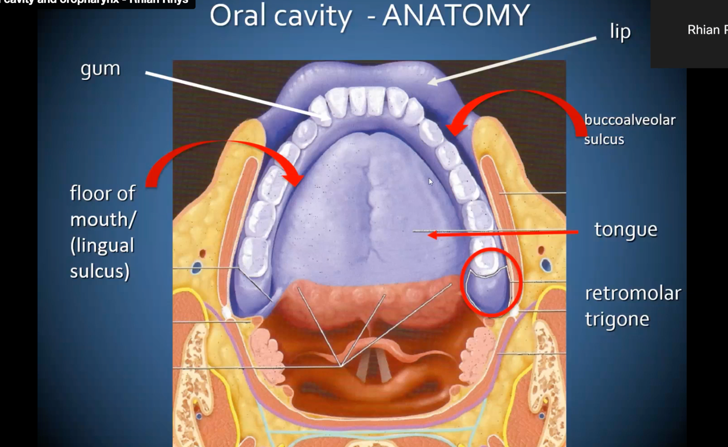

\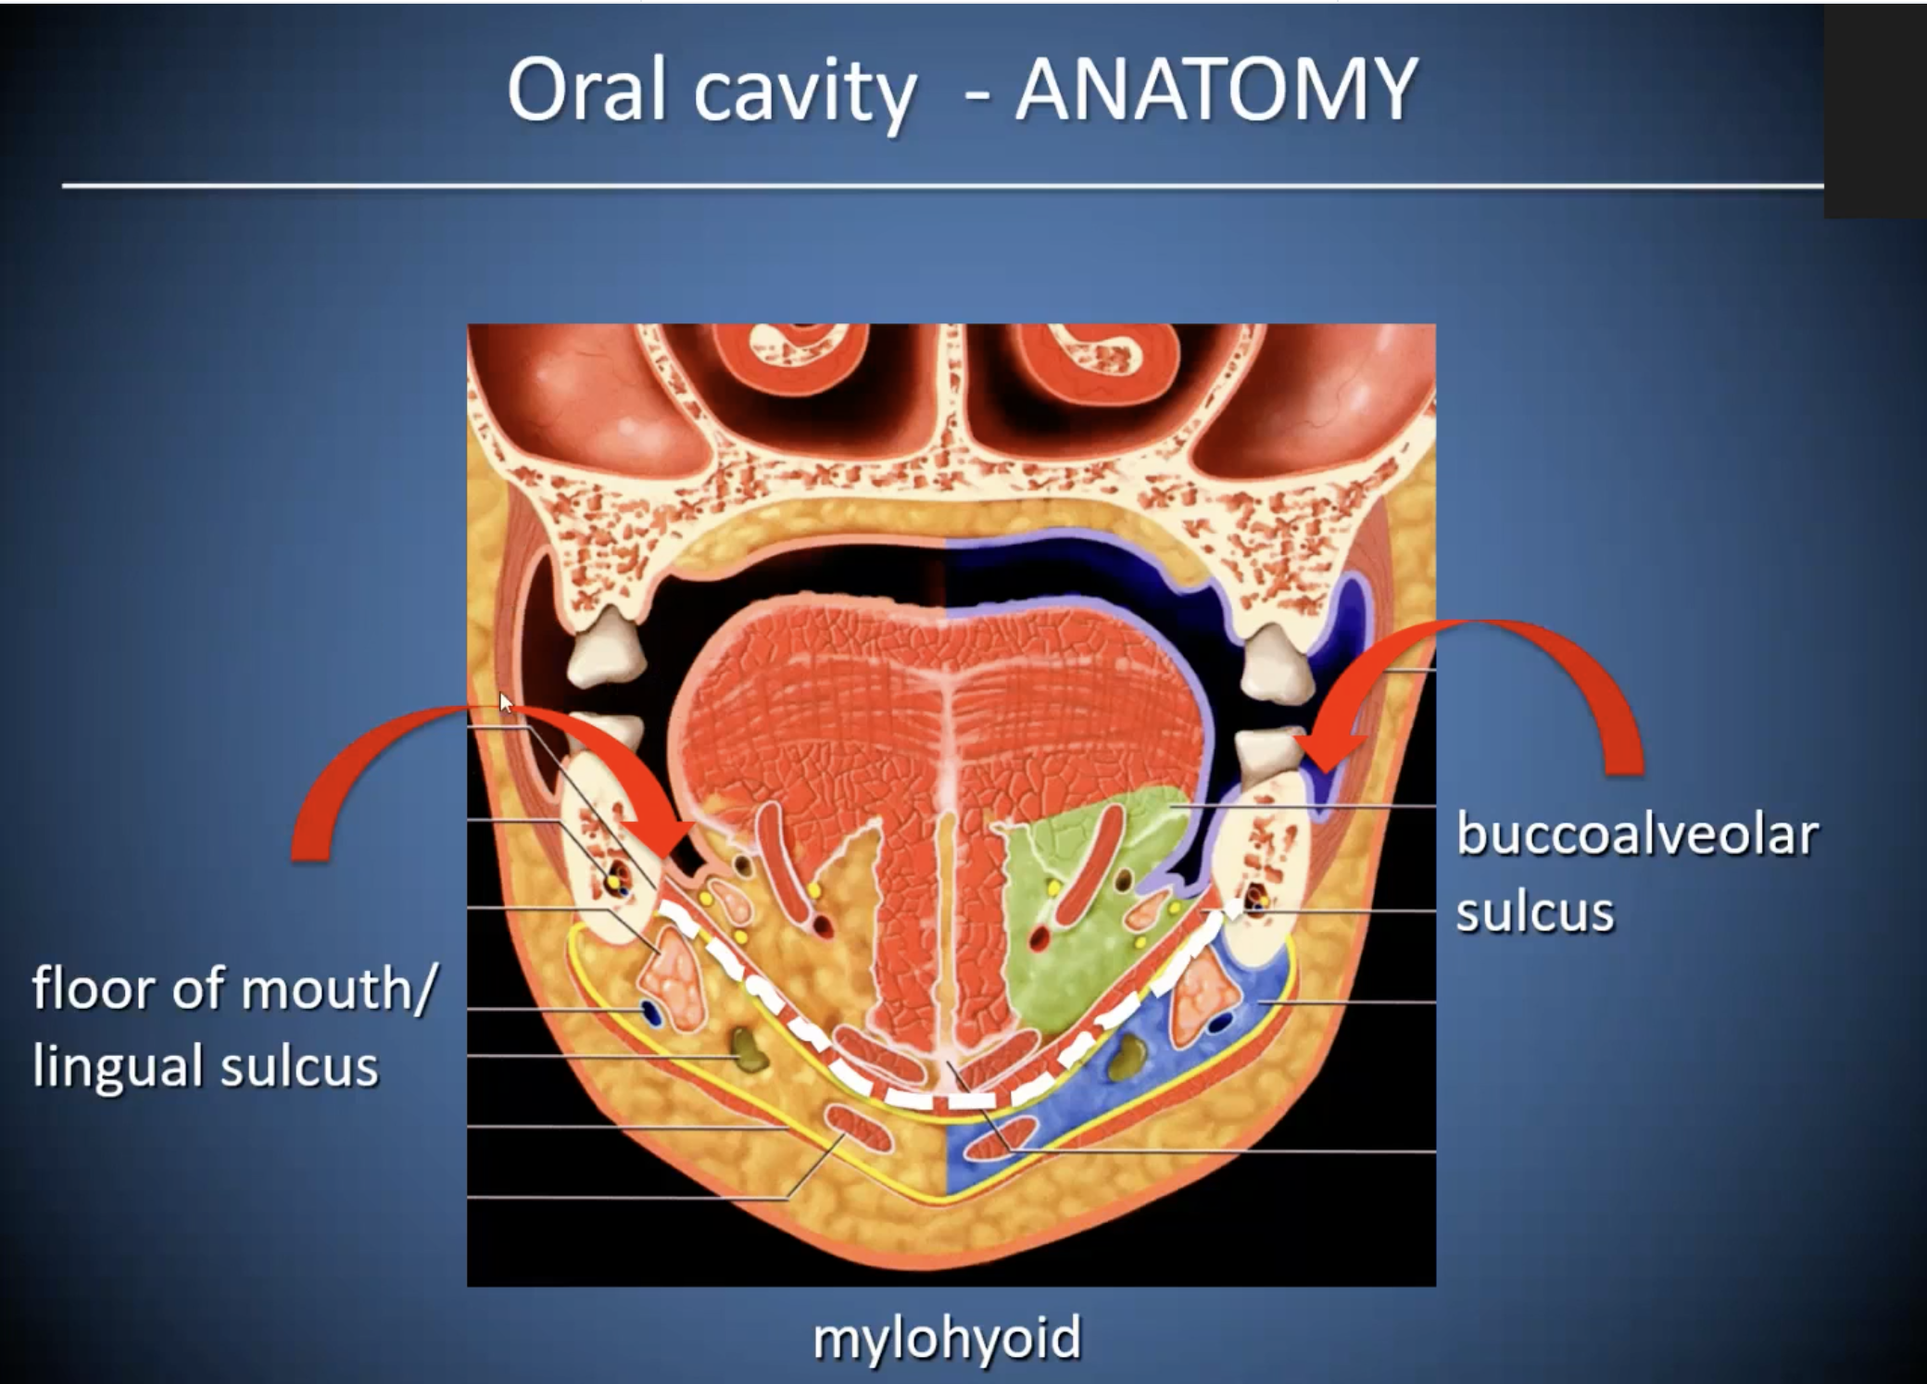

Normal subingual glands enhance- do not mistake with cacner – see below.

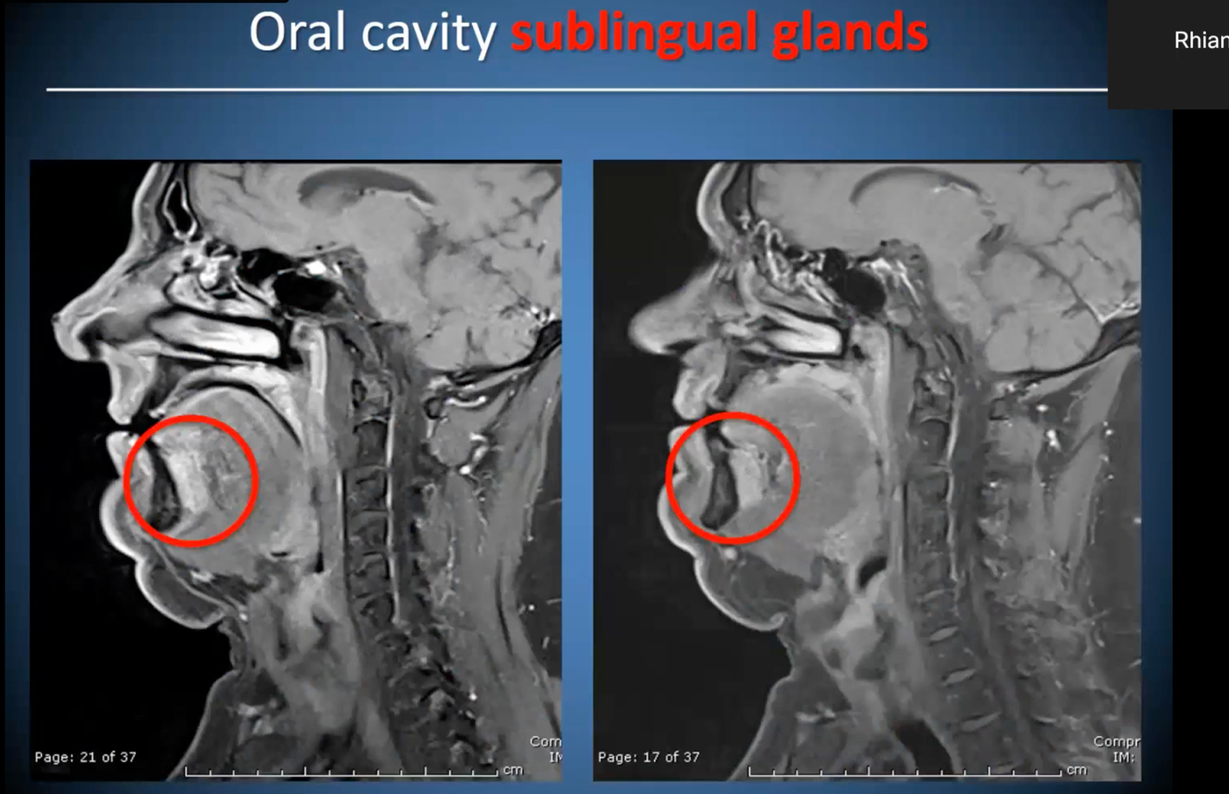

Treatent of oral cavity cancer is based on TNM 7 while prognosis is based on TNM 8 (which incorporates the DOI and HPV / p16 status).

Magic numbers are:

2cm(<2) : T1

And (2-4) : T2

4 cm(>4) : T3

T4- means locally advanced – if surgically resectable – 4a else 4b.

Nodal stage: magic numbers are

3 (<3) : N1

And (3-6): N2 (1 node = 1a, 2 node =1b, contralateral node = 2c)

6 (> 6): N3

Skin and bone involvement is always T4a (both in TNM7 and TNM8). But extrinsic muscle involvement has now been removed from TNM8 and this has been replaced by DOI.